Policy Participation Report: Hetch Hetchy Water Delivery System Serving the Bay Area
Snigdha Gurram

Hetch Hetchy is a dam that supplies water to the Bay Area, and it was built about 76-year-old as of now, so it started in 1914 and was completed in 1934. It is a 167 mile long that is driven by gravity to let the water flow to the areas it is met to go to. Hetch Hetchy is made up of “dams, reservoirs, tunnels, pump stations, aqueducts, and pipelines” (Hetch Hetchy Water and the Bay Area Economy). San Francisco Public Utilities Commission oversees managing and operating the Hetch Hetchy system which delivered about 260 million gallons of water per day to wholesale buyers. Almost 85% of the water comes from Hetch Hetchy for wholesale buyer while 15% comes from local sources (Hetch Hetchy Water and the Bay Area Economy). Hetch Hetchy Water Delivery System serves to 1.8 million businesses and about 2.4 million people in the Bay Area region. Most of the water that Hetch Hetchy receives is from the snow fall in the Sierra Nevada. The Hetch Hetchy water goes from Yosemite to San Francisco Bay Area with a little bit of the water running off to another direction (Hetch Hetchy system). Figure 1 shows all the places that the Hetch Hetchy water goes to supply other cities.
Figure 1
Hetch Hetchy regional water system path through the Bay Area
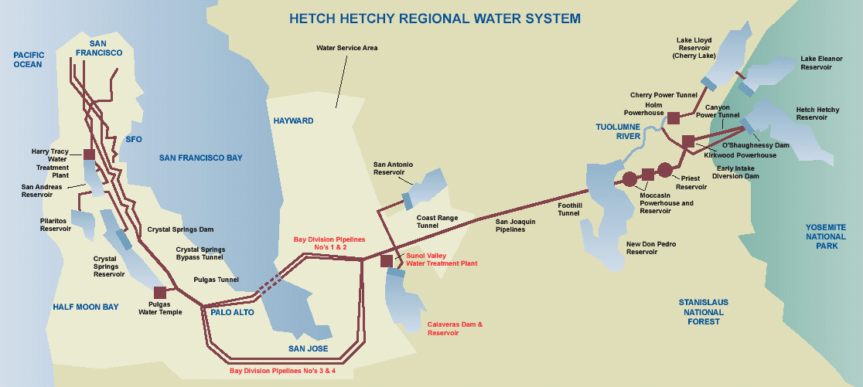
Note. Hetch Hetchy providing water to different cities and treatment plants. Hetch Hetchy system. Bay Area Water Supply and Conservation Agency, by Bawsca.
Hetch Hetchy provides 260 million gallons of water each day and travels long distances to reservoirs and stations to get treated (Hetch Hetchy system). Hetch Hetchy water quality is high which lets it avoid EPA filtration mandates (Hetch Hetchy Water and the Bay Area Economy 2002). The water treatment that the water goes through is Tesla Ultraviolet Treatment Facility which disinfects that water. Then the Sunol Valley Treatment Plant treats the water from the Calaveras and San Antonio supplies and stores the supply. Next the Harry Tracy Water Treatment Plant treats the water from Crystal Springs while the San Andreas supplies the water. The Bay Area and Peninsula water transmission systems have pipelines that divide the water to different areas (Water system). Although Hetch Hetchy provides water to many cities it was more to benefit the San Francisco Bay Area population. Understanding the amount of help that Hetch Hetchy provides to the Bay Area and cities around, figure 2 shows the exact cities that Hetch Hetchy provides water to.
Figure 2
Cities in the Bay Area that get water from Hetch Hetchy
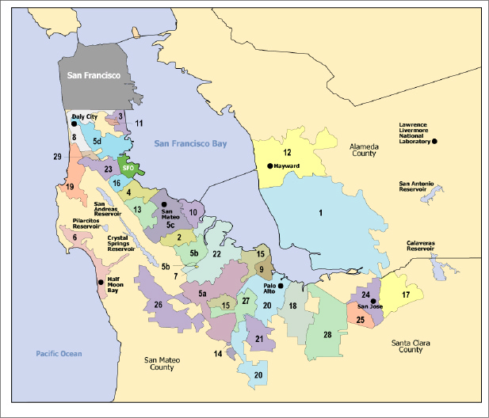

Note. The cities that get water from Hetch Hetchy. Hetch Hetchy Water and the Bay Area Economy (p. 4), by Bay Area Economy, 2002.
Although the water from Hetch Hetchy is supplied to the Bay Area there are many sections that are missing. Some of these places that are missing are parts of San Mateo County, Santa Clara County, and Alameda County. 30% of the water demand that San Francisco receives is from the business and institution people and 25% is from the Bay Area Water Users Association for service territory. In the 2002 report, it was estimated that the “total demand for Hetch Hetchy water is expected to grow to 303 mgd in 2030 and 310 mgd by 2050” (Hetch Hetchy Water and the Bay Area Economy 2002). SFPUC supplies and operates the Hetch Hetchy Water System, and the system is made up of over 1,250 miles of pipelines, 12 in-city reservoirs, and eight water tanks that have 413 million gallons of water in them (Water system).
Since Hetch Hetchy provided water for the Bay Area, which is in California. There earthquakes are inevitable. Hetch Hetchy goes across about 5 active faults. These faults are: “The San Andreas, Hayward, Calaveras, Greenville, and the Great Valley Fault Zone”. Hetch Hetchy had a lot of controversy of it being the source of water for the Bay Area after the 1906 San Francisco earthquake. After an earthquake, there needs to be a check of all the equipment to make sure everything is okay. This is indicated in Figure 3 for the estimated number of days it could take to restore the systems (Hetch Hetchy Water and the Bay Area Economy 2002).
Figure 3
Estimated SFPUC System Restoration Times After an Earthquake
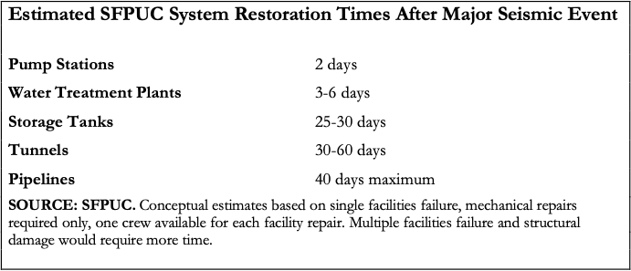
Note. These are just the estimated number of days that it could take to restore the systems back to normal. From Hetch Hetchy Water and the Bay Area Economy (p.10), by Bay Area Economy, 2002.
Since Hetch Hetchy is extremely helpful in providing a source of water for the Bay Area it could have more potential in providing to more people. There should be a way for policy and decision makers to communicate with people and for people to communicate with them on ways to use to water in sustainable ways because of the droughts that have been occurring in California. There should also be a way for Hetch Hetchy to deliver water to more people in California. A great example of what can be attempted by SFPUC to make Hetch Hetchy a more sustainable and protected water supply is an organization called Tuolumne River Trust.
Tuolumne River Trust is a non-profit organization that is trying to get a healthy and sustainable river whose ecosystem and communities around the river are educated, advocate, and do restoration work to help the river. This non-profit is in Modesto, California. The Tuolumne River starts at Yosemite National Park at 13,000 feet and is 149 miles long. The water from there irrigates more than 200,000 acres of agricultural land in Stanislaus County and this food is eaten by people all over the United States. This river also provides drinking water to the San Francisco Bay Area to over 2.7 million people. In the Tuolumne River Trust website, they provide a section dedicated to member of the community getting involved into advocacy of improving the river. They also promote a stewardship of the Tuolumne River to have a healthy watershed. The things that are included in their healthy vision for the Tuolumne River Trust are “teeming with fish and wildlife, safe for drinking, fishing and swimming, welcoming for rafting, kayaking, and other river sports, and held in trust as a refuge for our children and grandchildren”. Their goal is to have a healthy and happy environment that people can enjoy for generations by being able to interact with it in ways that are fun but also safe (Tuolumne River Trust).
Hetch Hetchy and the Tuolumne River Trust have a few parts in common. Hetch Hetchy has the Tuolumne River runs through, of which the Tuolumne River Trust takes can of the recreational and environmental activities to take care of it. Since Hetch Hetchy is a large area there are other activities that are taken care of that include hiking, lookout points, visiting the falls, and viewing the dam that John Muir tried to stop. Hetch Hetchy has been doing wonderfully in transferring water to areas in the Bay Area while making a sustainable and healthy environmental choice with people being able to do some recreational activities. Along with the incorporation of Tuolumne River Trust helps to keep the river healthy while allowing people to have recreational activities.
Reference:
Hetch Hetchy Reservoir and water system. Water Education Foundation. (n.d.). from https://www.watereducation.org/aquapedia/hetch-hetchy-reservoir-and-water-system
Hetch Hetchy system. Bay Area Water Supply and Conservation Agency. (n.d.)., from https://bawsca.org/water/supply/hetchhetchy
Hetch Hetchy Water and the Bay Area Economy. (2002, October). from http://www.bayareaeconomy.org/files/pdf/hetchhetchyfinal2.pdf
Tuolumne River Trust. (n.d.). from https://www.tuolumne.org/
U.S. Department of the Interior. (n.d.). Hetch Hetchy. National Parks Service. from https://www.nps.gov/yose/planyourvisit/hh.htm
Water system. SFPUC. (n.d.). from https://sfpuc.org/about-us/our-systems/water-system

